**Heroes of Pymoli Purchase Data Analysis – Key Takeaways**

* **Heroes of Pymoli has a user base that skews heavily male and between the ages of 15 – 29.** Roughly 84% of users identify as male, and just over three-fourths of users are between the ages of 15 – 29. Further, the game’s user base is heavily concentrated among 20 – 24 year-olds, reflecting approximately 45% of the game’s total user base.

**Fig. 1: Heroes of Pymoli User Demographics by Gender and Age**

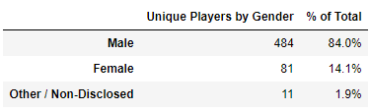

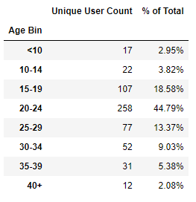

* **Purchase concentration in the game by age group and gender is largely consistent with the overall demographic profile of the user base, while females spend slightly more on average than males.**

**Fig 2. Heroes of Pymoli Purchaser Data Analysis**

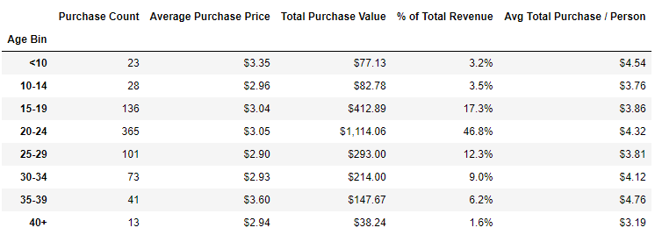

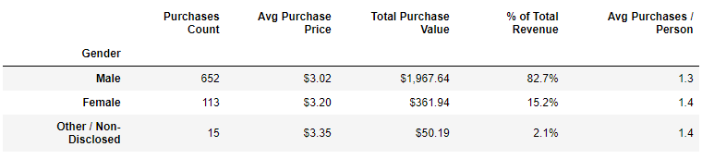

* **Player spend is highly diffuse, with the top 5 players collectively representing just over 3% of overall revenue.**

**Fig. 3 Revenue Concentration Among Top 5 Spending Players**

